No. of Pages | 4
No. of Questions | 3
B
Department of Computer Science and Engineering
MIDTERM EXAMINATION Summer 2018

CSE421: Computer Network
Total Marks: 45 Time Allowed: 50 minutes
- Answer ALL THREE (3) questions
- Figure in bracket [] next to each question indicates marks for that question

Question 1

- An organization is given the block 200.20.96.0/23. The organization takes this block to distribute to Three sub-networks and 2 WAN-Links as shown in the Figure No. 1 below. Show how you can efficiently distribute the given block to create the required subnets using VLSM. Show basic calculations. [10 Marks]

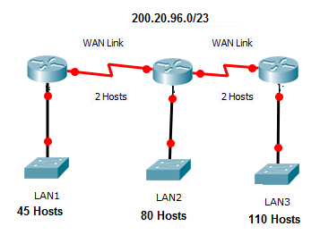
Figure no. 1

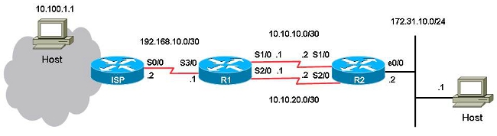
Figure no. 2

- Refer to the topology in Figure 2 above. Since this is a stub network, static routes are preferable.
ip route 0.0.0.0 0.0.0.0 _______________
  - The above default static route command should be applied in which router/s and what should be the written in the blank line?
  - To create a floating default static route, what are the modifications to be done to the above command and in which router/s will you implement it? [2+3 marks]

Question 2
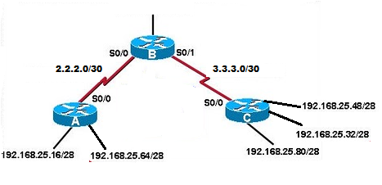
Figure no. 3
- Refer to Figure no.3. For both Router A and Router C auto-summary is enabled. What kind of problem will this create for Router B and how do we solve this problem? [4+1marks]
- A router learns a route to 100.18.20.0/24 from its neighbour, that it is 4 hops away. Suddenly it stops receiving updates regarding this route to 100.18.20.0/24 network from its neighbour.
  - What will it do if it does not receive any route update of 100.18.20.0/24 in the next 6 updates from its neighbour? [4 marks]
  - What will the router do if it receives the update for 100.18.20.0/24 network in the 9th update sent by its neighbour? [2 marks]

Figure no. 4

- The Gateway Router in the above Figure no.4 is running RIP routing protocol. The network administrator does not want to send any RIP updates via serial interface s0/0. How can this be implemented? Why does the administrator not want to send any RIP updates through the serial interface? [2+2 marks]

Question 3

- What is the purpose of Hello packets? What are the timers associated with these hello packets? [4 marks]
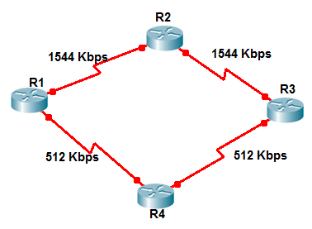

Figure no. 5

- All the routers in the above Figure no.5 are running OSPF. What does OSPF use to calculate the cost of a path? Now the network administrator has asked you to use the bandwidth command in router R1, R4 and R3 but not R2, why? [2+3 marks]
- Link state routing protocol uses Dijkstra’s algorithm. Now refer to Figure no. 6, using Dijkstra’s algorithm, compute the shortest path from Y to all other remote networks. Use the table provided. [6 marks]

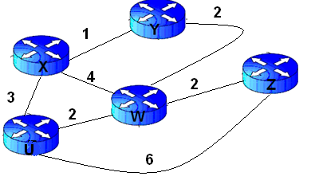
Figure no. 6

THE END

Question 3 (c)
ID:

SECTION:
SET B

Step No. | N’

